The Exchange Rates app was built with Angular version 6.1.1 (https://github.com/angular/angular-cli) version 6.1.1. ngBootstrap has been used to style the components.

Show exchange rates

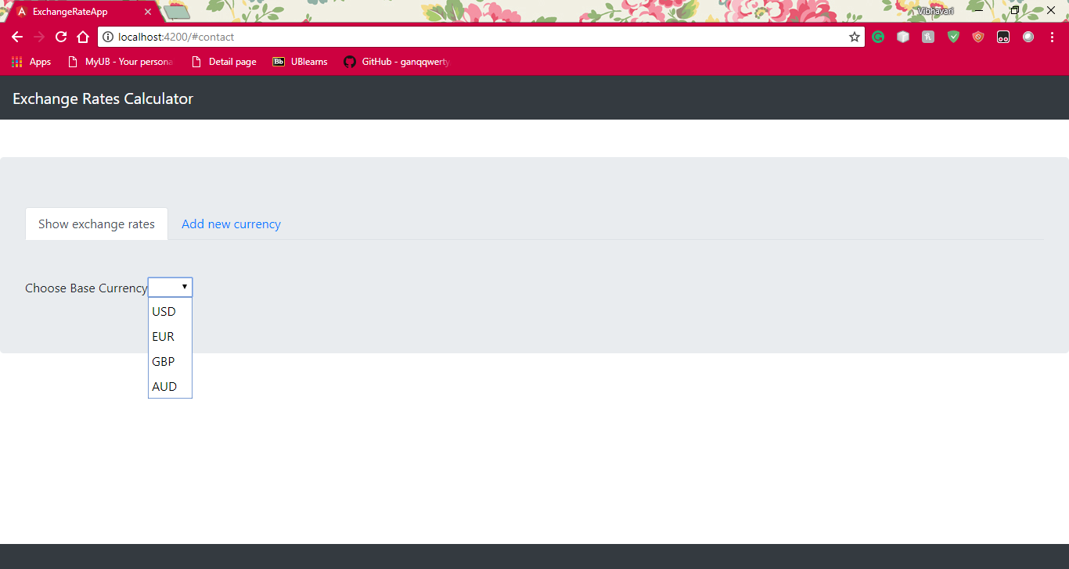

The selected currency does not show up in the list. The date is displayed in MM/dd/YYYY format

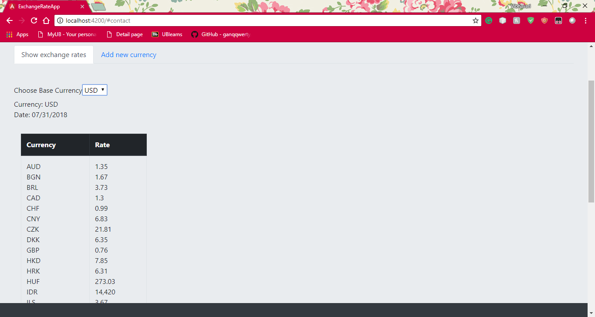

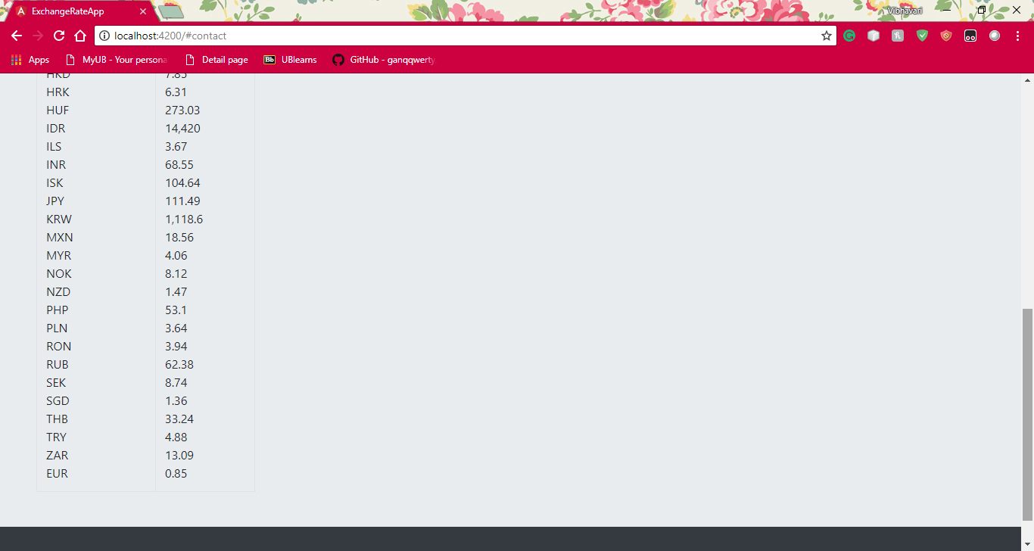

Adding new currency

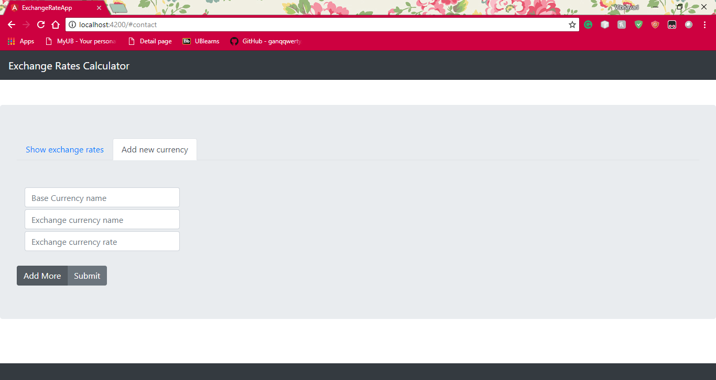

At least one exchange currency name and rate have to be entered.

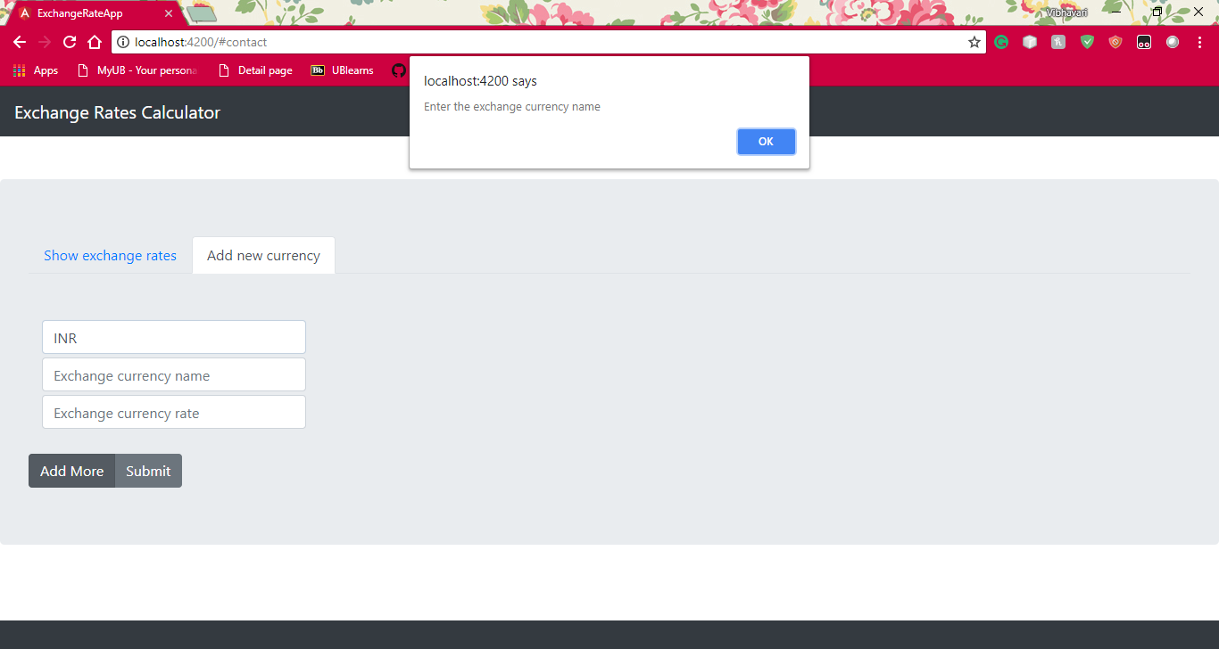

More exchange rates can be added by clicking on Add More

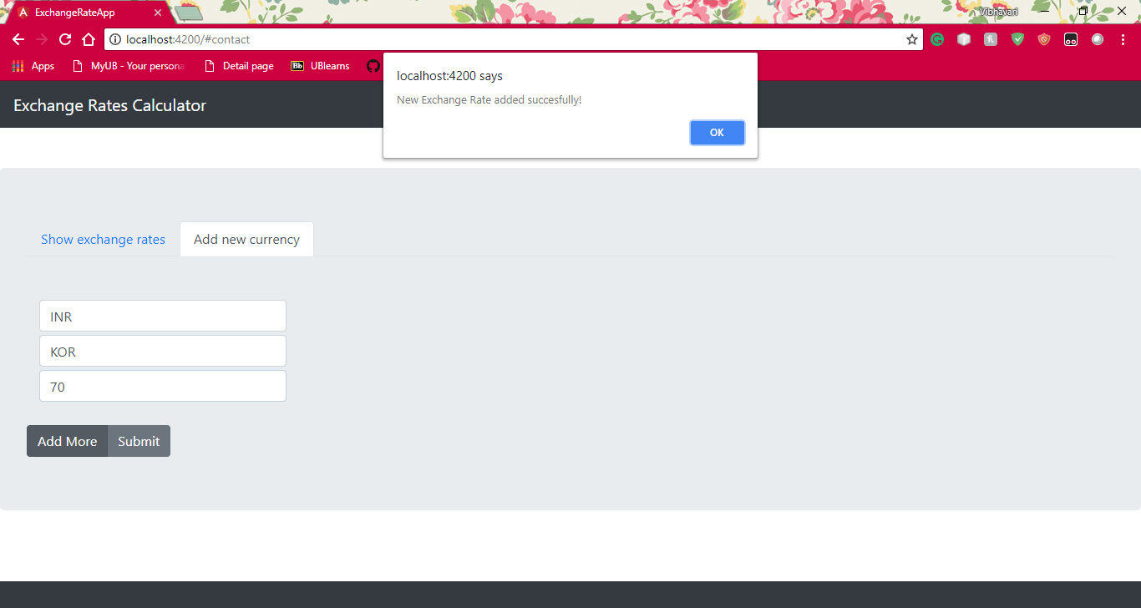

Exchange rate must be a number

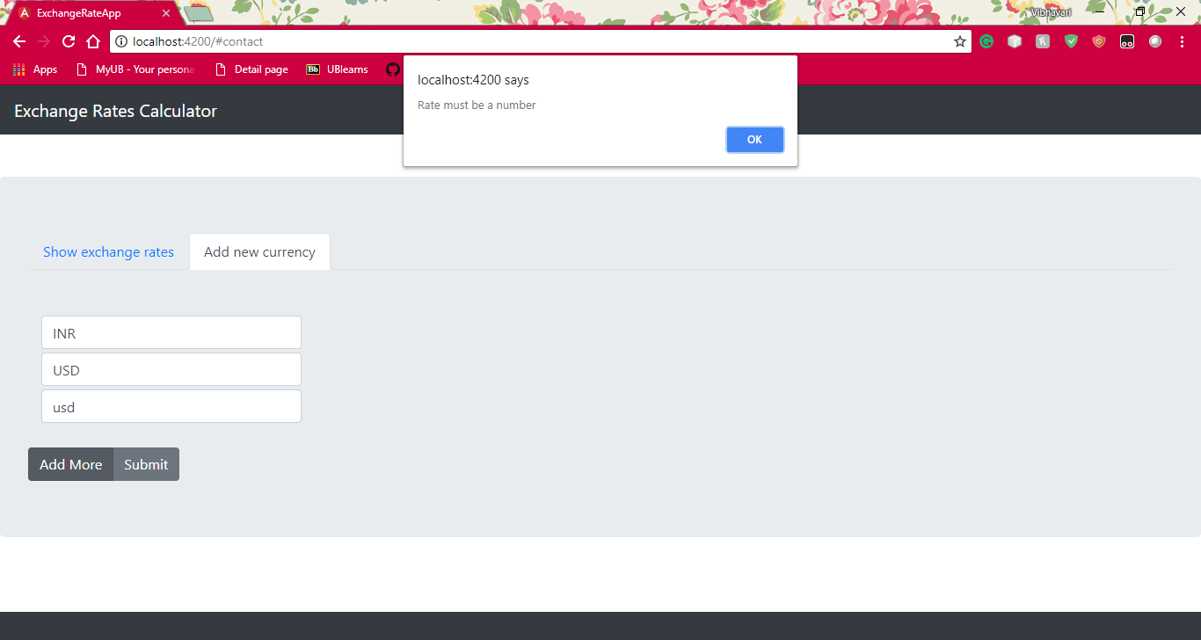

Click on Submit to successfully add the base and exchange rates

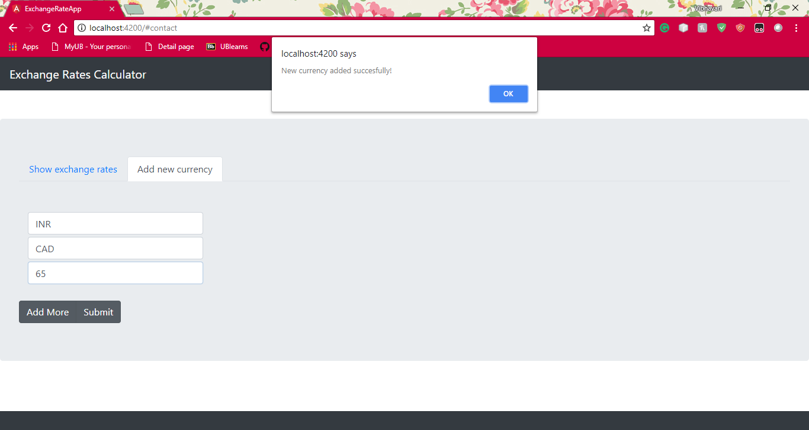

The new rate gets added to the dropdown in exchange rates tab

